 |  |  |  |  |  |  | Ni
 | 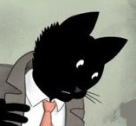 |  |  | John Chatterton |  |  | 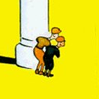
 | Emil |  |  | 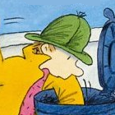 |  |  | Nick Nase
 | 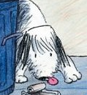 |  |  | Schnuffel |  |  | 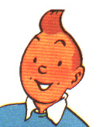
 | Tim |  |  | 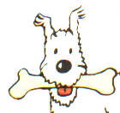 |  |  | Struppi

